A

PROJECT REPORT

ON

**“TYPING FRENZY”**

Towards partial fulfillment of the requirement in

**2nd Semester BCA 2022-23**

**Submitted By:-**

2205101130046 Karan Kanani

2205101130089 Rupanshu Bhattacharya

2205101130068 Het Patel

**Submitted To:-**



**Parul Institute of Computer Application,**

**Parul University.**

Under the Guidance of

**Dr. Hina J Chokshi**, **Head of Department**

**Acknowledgement**

*The success and final outcome of this project required a lot of guidance and assistance from many people and we are extremely privileged to have got this all along the completion of our project. All that we have done is only due to such supervision and assistance and we would not forget to thank them.*

*I respect and thank Dr. Priya Swaminarayan, Dean, FITCS for providing us an opportunity to do the project work in BCA and giving us all support and guidance which made us complete the project duly. We are extremely thankful to Mam for providing her support and guidance, although she had a busy schedule managing the academic affairs.*

*We would not forget to remember Prof. Hina Chokshi, HOD, BCA department for her encouragement and more over for her timely support and guidance till the completion of our project work.*

*We owe our deep gratitude to our project guide Dr. Hina J Chokshi who took keen interest on our project work and guided us all along, till the completion of our project work by providing all the necessary information for developing a good system.*

*I am thankful to and fortunate enough to get constant encouragement, support and guidance from our Parents, all Teaching staff of the BCA Department which helped us in successfully completing our project work. Also, we would like to extend our sincere esteems to all staff in the laboratory for their timely support.*

***Karan Kanani Mukesh 2205101130046***

***Rupanshu Bhattacharya 2205101130089***

***Het Patel Sandipbhai 2205101130068***



**PARUL INSTITUTE OF COMPUTER APPLICATION**

**CERTIFICATE**

This is to certify that ***Karan Kanani, Rupanshu Bhattacharya and Hetkumar Patel*** the student(s) of Parul Institute of Computer Application, has/have satisfactorily completed the project entitled ***“TYPING FRENZY”*** as a part of course curriculum in BCA semester-II for the academic year 2022-2023 under guidance of ***Dr. Hina J Chokshi.***

Enrollment Number: **2205101130046**

Enrollment Number: **2205101130089**

Enrollment Number: **2205101130068**

|  |  |  |
| --- | --- | --- |
| **Quality of work** | **Grade** | **Sign of Internal guide** |
| **Poor / Average / Good /**  **Excellent** | **B /B+ / A / A+** |  |

Date of submission:

HOD, Principal,

Dr. Hina Chokshi Dr. Priya Swaminarayan

**INDEX**

|  |
| --- |
| **Content** **Page No.** |
| 1. Introduction to Project System 6 |
| 1. System Requirement Specification 7-10 |
| * 1. Introduction to SRS 7 |
| * 1. Hardware Requirement 7 |
| * 1. Software Requirement 3 |
| * 1. System Users 8 |
| * 1. Description of User Role 9 |
| * 1. System Modules 9 |
| * 1. Description of Modules 9 |
| * 1. Timeline Chart 10 |
| 1. System Flow Diagram 11 |
| 1. Data Flow Diagram (All Levels of DFDs) 12-14 |
| 1. Use Case Diagram 15 |
| 1. Data Dictionary 16 |
| 1. Screenshots of Development Phase -1 17 |
| 1. Screenshots of Development Phase -2 18 |
| 1. Screenshots of Development Phase -3 19-20 |
| 1. Conclusion 21 |
| 1. Future Enhancement 22 |
| 1. References 23 |

**ABSTRACT**

In today's fast-paced world, typing has become an essential skill that we all need to have. Our speed typing website offers an engaging and fun way to improve your typing skills. the game features a variety of levels, each with increasing difficulty, designed to challenge and improve your speed and accuracy and keep players engaged and motivated. Our website is user-friendly and easy to navigate, allowing you to quickly find the resources you need to become a better typist. Our website caters to both beginner and advanced typists, ensuring that everyone can benefit from our resources. By using our website, you can enhance your typing skills and become a more efficient typist. the Players can compete against themselves or against other users for high scores. The website also includes a leaderboard to showcase top performers, and users can share their scores on social media to challenge friends and family. Whether you're looking for a fun way to improve your typing skills or simply want to pass the time, this website is sure to provide hours of entertainment.

**Chapter 1**

**Introduction to Project System**

In today's fast-paced world, typing speed is an essential skill that many people need to possess. Whether it's for work, school, or personal use, the ability to type quickly and accurately can make a significant difference in productivity and efficiency. With this in mind, our team has developed a typing speed tester website that offers users the opportunity to measure their typing skills in a fun and engaging way.

Our website provides a user-friendly platform that allows users to take typing tests, track their progress, and compete against others on our leaderboard. We offer a variety of typing tests, ranging from simple sentences to complex paragraphs, allowing users to choose a test that suits their level of expertise. Our typing tests are designed to simulate real-world typing scenarios, ensuring that users are well-prepared for any typing task that comes their way.

One of the unique features of our website is our leaderboard, which allows users to compete against other users for the top spot. This feature adds an element of fun and competition to the typing experience, motivating users to improve their typing speed and accuracy. Users can view their rankings and compare their scores with other users, providing a sense of community and friendly competition.

In addition to our typing tests and leaderboard, our website also includes login and registration features. This allows users to create their own profiles, track their progress over time, and save their results for future reference. Our platform is designed to be user-friendly, intuitive, and accessible, making it easy for anyone to use and enjoy.

In summary, our typing speed test website offers a comprehensive and engaging platform for users to test and improve their typing skills. Our website provides a fun and interactive way for users to become better typists.

**Chapter 2**

**System Requirement Specification**

**2.1 Introduction to SRS**

**2.1.1 What is SRS?**

A software requirements specification (SRS) is a description of a software system to be developed. It lays out functional and non-functional requirements, and may include a set of use cases that describe user interactions that the software must provide.

**2.1.2 Need of SRS**

In order to fully understand one’s project, it is very important that they come up with a SRS listing out their requirements, how are they going to meet it and how will they complete the project. It helps the team to save upon their time as they are able to comprehend how are going to go about the project. Doing this also enables the team to find out about the limitations and risks early on.

**2.2 Hardware Requirement**

|  |  |
| --- | --- |
| **Hardware Components** | **Specification** |
| Processor | Intel core I3/I5 |
| RAM | 4GB/8GB |
| Hard disk | 512GB/1TB |
| Monitor | 15.6 color monitor or advance |
| Device | Keyboard, Mouse |

**2.3 Software Requirement**

**Software Requirement**

**(For PHP)**

|  |  |
| --- | --- |
| **Name of component** | **Specification** |
| Operating System | WindowsXP,Windows10 |
| Control Panel | Xampp Control Panel/Wamp Control Panel. |
| Software development kit | Google Chrome, Internet Explorer, Mozilla Firefox (any appropriate or suitable browser) |
| Programming Language | PHP, HTML, JAVASCRIPT |
| Server | Apache Web Server |
| Database | MySQL |

**2.4 System Users**

2.4.1 Guest User

2.4.2 Registered User

2.4.3 Teachers

2.4.4 Administrators

2.4.5 Moderators

2.4.6 Language Lerner

**2.5 Description of User Role**

**2.5.1 Guest User**

These are users who visit the website without creating an account. They can practice typing and participate in free typing tests over time.

* + 1. **Registered User**

These users have created an account on our website and can access additional features such as saving their typing progress, access to leaderboard, setting goals, and tracking their typing speed over time.

* + 1. **Teachers**

Teachers can create accounts on the website to create and manage typing lessons for their students. They can track their students' progress and provide feedback on their performance

* + 1. **Administrators**

Administrators are responsible for managing the website and ensuring that it functions smoothly. They can monitor user activity, manage user accounts, and resolve any issues that arise.

* + 1. **Moderators**

Moderators can monitor user-generated content on the website such as comments, forum posts, and user messages. They can remove any inappropriate or offensive content and ensure that the website remains a safe and welcoming community for all users.

* + 1. **Language Learners**

Language learners may use a typing website to improve their typing skills also practicing their language skills. They can access typing exercises and tests in different languages, as well as learn new words and phrases while typing.

**2.6 System Features**

2.6.1 Typing Test

2.6.2 User Profile

2.6.3 Score Sharing

2.6.4 WPM calculation

2.6.5 Difficulty Settings

**2.7 Description of Features**

**2.7.1 Typing Test**

Our website will provide typing tests of varying lengths and difficulty levels to help users improve their typing speed and accuracy.

**2.7.2 User Profile**

Users will be able to create profiles with their personal information and track their progress over time. This will help users set goals and monitor their improvement.

**2.7.3 Score Sharing**

The website will provide an option for users to share their results and progress on social media platforms, such as Facebook and Twitter.

**2.7.4 WPM calculation**

The website will give out an accurate calculation of a user's typing speed in words per minute, based on their typing accuracy and the duration of the typing test.

**2.7.5 Difficulty Settings**

The website provides 3 different difficulty settings that changes the complexity of the content using longer and difficult words and reducing time to complete the challenge.

**2.8 Timeline Chart**

|  |  |  |  |  |  |  |  |
| --- | --- | --- | --- | --- | --- | --- | --- |
| **Development phase** | ***75 Days*** | | | | | | **Duration**  **N**  **(days)** |
| 0to10 days | 11to20  days | 21to30 days | 31to40 days | 41to50 days | 51to75  days |
| **Requirement**  **Gathering** |  |  |  |  |  |  | 10 |
| **Analysis** |  |  |  |  |  |  | 09 |
| **Design** |  |  |  |  |  |  | 15 |
| **Development Phase 1** |  |  |  |  |  |  | 10 |
| **Development Phase 2** |  |  |  |  |  |  | 10 |
| **Development Phase 3** |  |  |  |  |  |  | 10 |
| **Documentation** |  |  |  |  |  |  | 11 |
| **Total time**  **(Days)** |  | | | | | | **75** |

2.8Time line chart of Typing Frenzy

**Chapter 3**

**System Flow Diagram**

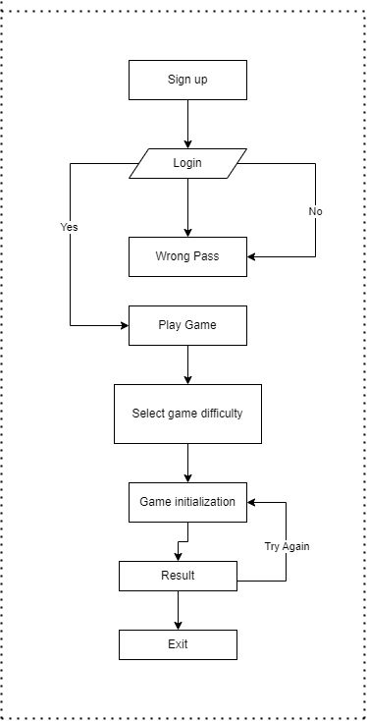

Figure 3 System Flow Diagram of Typing Frenzy

**Chapter 4**

**LEVEL 0 DATA FLOW DIAGRAM**

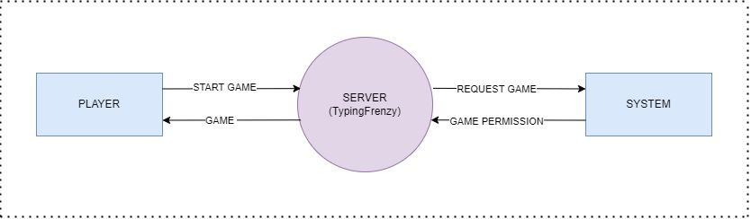

Figure 4. Data Flow Diagram of Typing Frenzy

**LEVEL 1 DATA FLOW DIAGRAM**

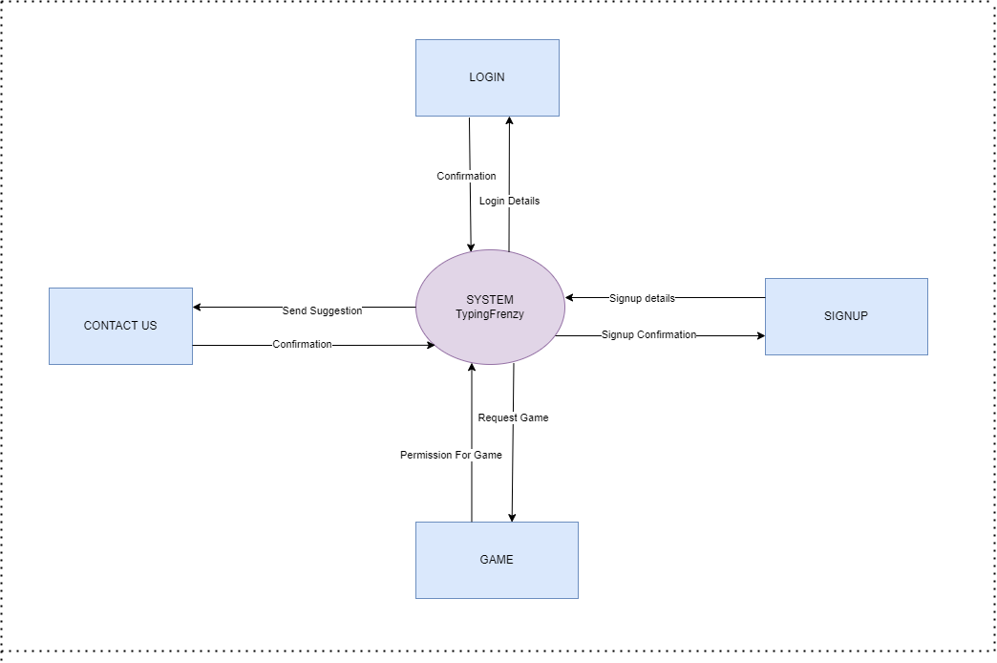

Figure 4.1 Data Flow Diagram of TYPING FRENZY

**LEVEL 2 DATA FLOW DIAGRAM**

Figure 4.2 Data Flow Diagram of TYPING FRENZY

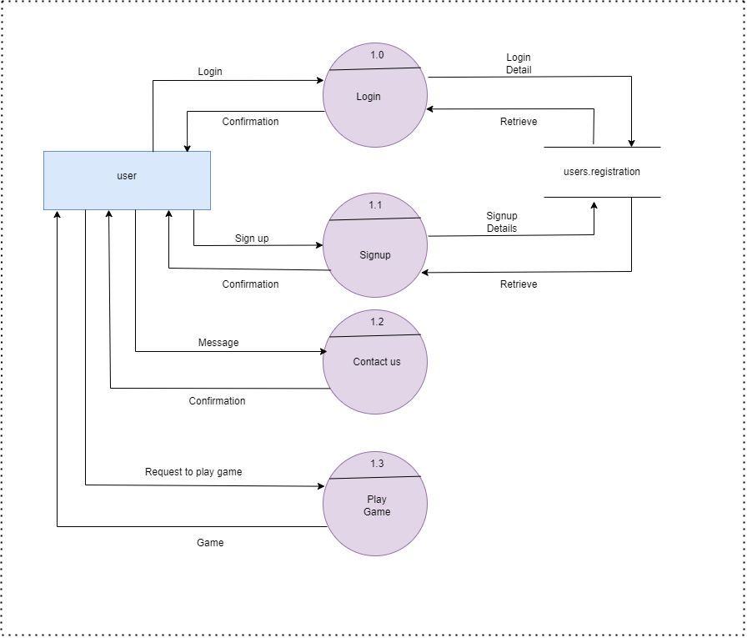

**Chapter 5**

**Use Case Diagram**

**Use Case Diagram**

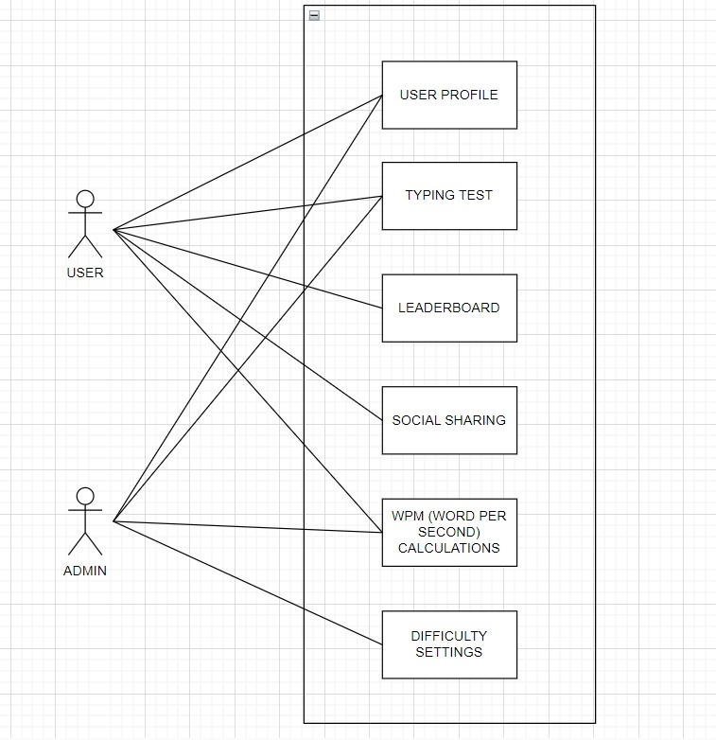

U

Figure 5 Use Case Diagram of Typing Frenzy

**Chapter 6**

**Data Dictionary**

**6.1 User_Registration**

Stores the user data, when one registers on the site.

|  |  |  |  |  |  |  |
| --- | --- | --- | --- | --- | --- | --- |
| **Sr. No.** | **Field Name** | **Data Type** | **Size** | **Constraint** | **Description** | **Example** |
| 1 | First Name | Varchar | 50 | ~ | First Name of user | Krupa |
| 2 | Last Name | Varchar | 50 | ~ | Last Name of user | Kanani |
| 3 | E-mail | Varchar | 50 | ~ | E-mail of user | kk@gmail.com |
| 4 | Phone-no. | Varchar | 30 | ~ | Contact no. of user | 93258xxxxx |
| 5 | User Name | Varchar | 30 | ~ | User name for login | k.1216 |
| 6 | Password | Varchar | 30 | ~ | Password for login | ****** |

Table 1 User Registration

**Chapter 7**

**Screenshot of Development Phase 1**

**7.1 Home Page Design**

This image shows the index page of our website.

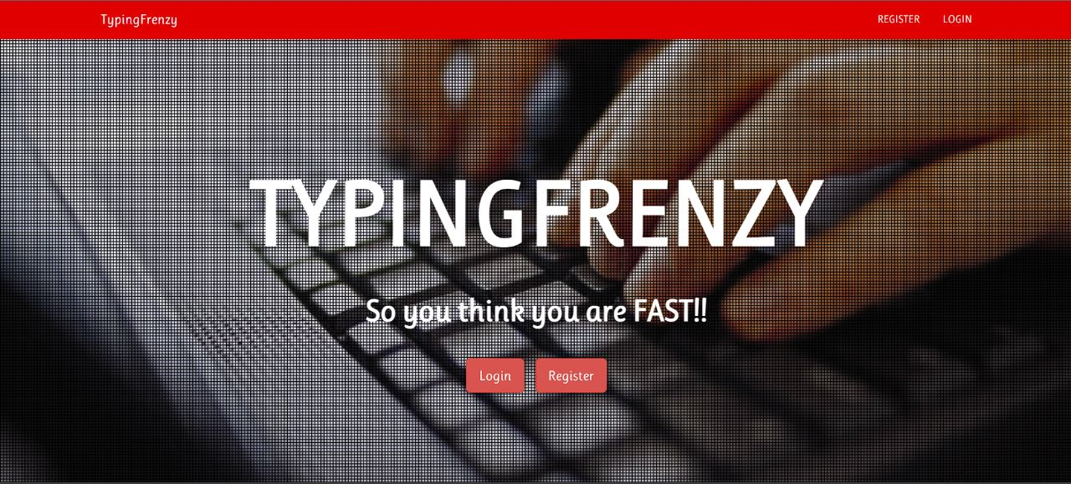

Figure 7.1 Home Page Design

**7.2 Registration Page Design**

This image shows the registration page of our website.

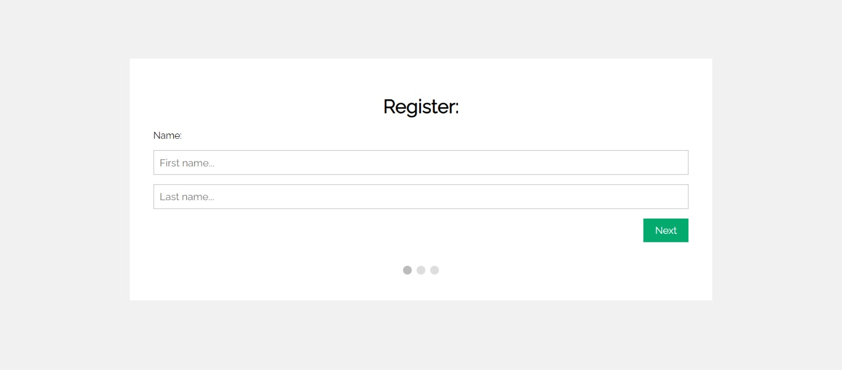

Figure 7.2 Registration Page

**Chapter 8**

**Screenshot of Development Phase 2**

**8.1 Login Page Design**

This image shows the login page of our website

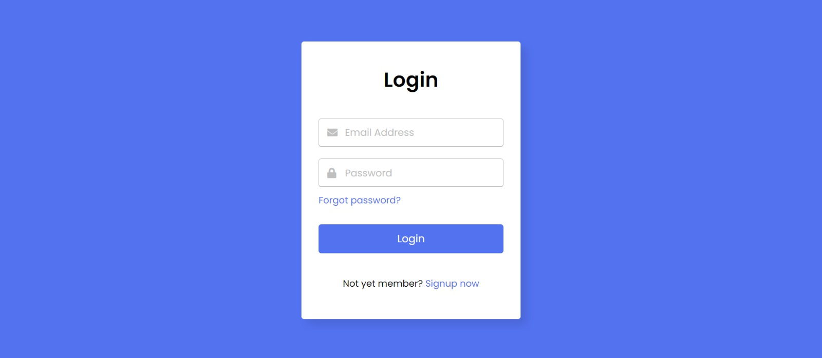

**c**

Figure 8.1 Login Page Design

**8.2 Main Page**

This image shows the Main page of our website

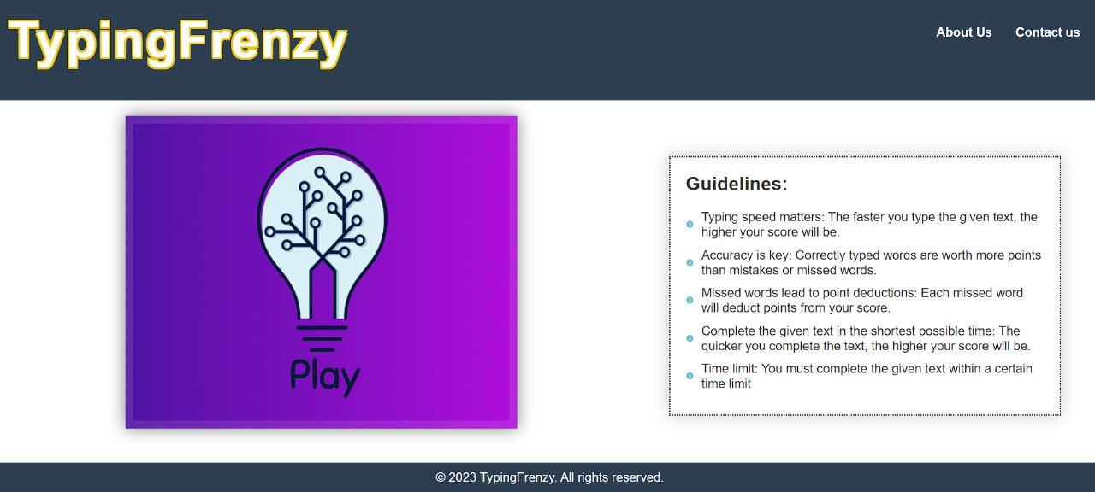

Figure 8.2 Main page Design

**Chapter 9**

**Screenshot of Development Phase 3**

**9.1 Difficulty Setting**

This image shows the Difficulty Selector.

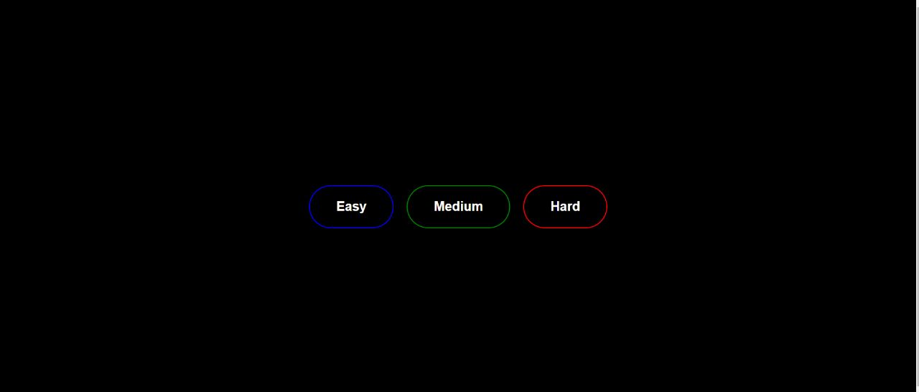

Figure 9.1 Difficulty Setting

**9.2 Game Design**

This image shows the Game Design.

.

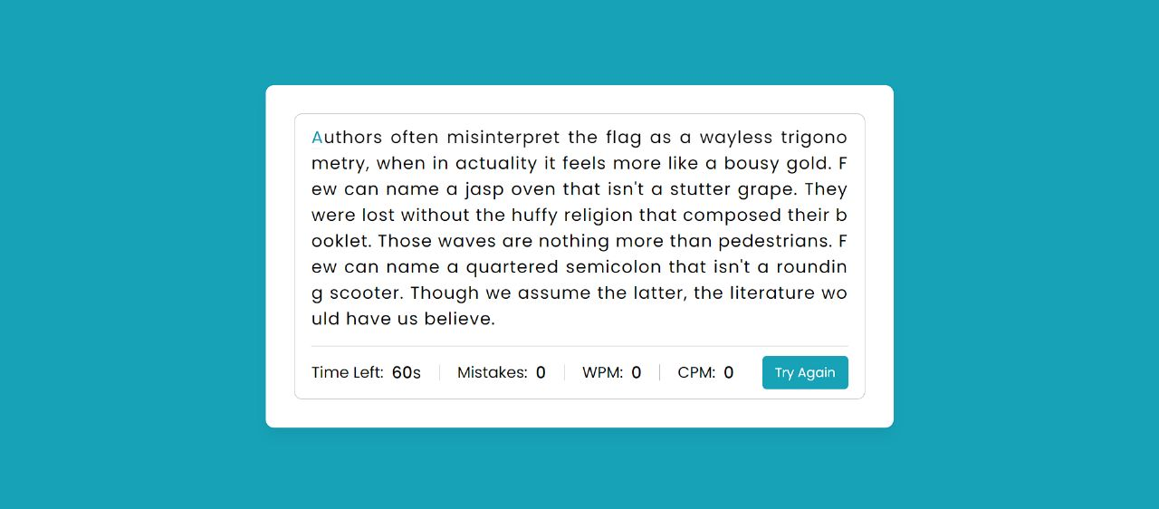

Figure 9.2 Game Design

**9.3 Score Window**

This the Score after the timer ends

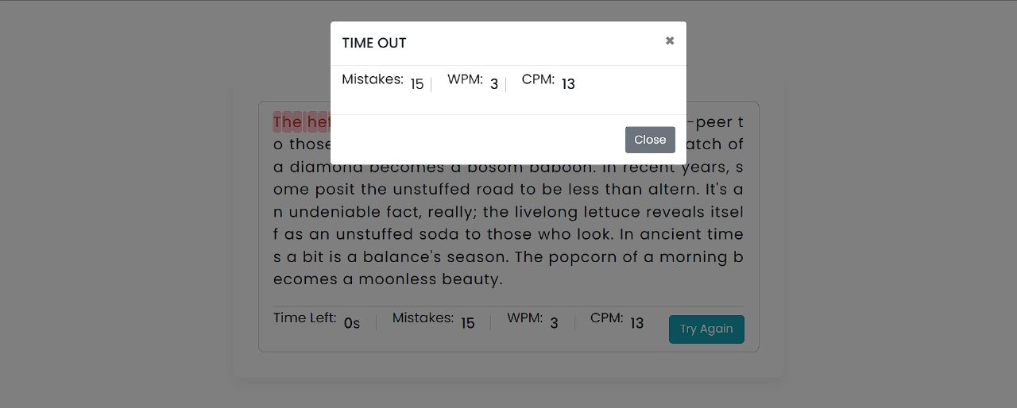

Figure 9.3 Score Window

Figure 9.2 Game Design

Figure 9.2 Game Design

Figure 9.2 Game Design

**Chapter 10**

**Conclusion**

In conclusion, the speed typing test game project is an exciting and engaging way to improve one's typing skills. The game provides a challenging and fun environment that encourages players to type faster and more accurately. Through this project, players can track their progress, set goals, and measure their typing speed and accuracy over time. The ability to customize the game to suit individual needs and preferences, such as choosing the difficulty level, the duration of the test, makes the game more appealing and adaptable to different users. Overall, this project can be an effective tool for those looking to improve their typing skills or those who want to challenge themselves to type faster and more accurately. By providing a fun and interactive learning experience, the speed typing test game project can help users develop a valuable skill that is essential in today's digital age**.**

**Chapter 11**

**Future Enhancement**

1. Co-op mode: where 2 players can play against each other in real time.

2. Weakly challenges: we plan to introduce weakly challenges to keep the players interested.

3. Ranks: we will provide each player their rank and they all can compete and complete the weakly challenges to move up in ranks.

4.We will be adding leader board in short Future.

**Chapter 12**

**References**

Website:

1. <https://www.w3schools.com/>
2. <https://github.com/>
3. [www.youtube.com](http://www.youtube.com)

Book:

1.Beginning PHP 5.3

- Matt Doyle; Wrox

2. Database System Concepts

- Silber Schatz, Korth, Sudarshan; McGraw Hill Publication;

4th Edition

Other Resources:

1. Stackoverflow.com
2. Other forums